Blackburns’ Chapel Windows
The Garden

The windows are offered as a pilgrimage of light paralleling the life of Christ and all life as well as a celebration of divine design made manifest on earth. Inspiration comes from the painting at the front of the church - the Garden of Gethsemane – specifically the poppies and their reflection. As a quiet place of reflection away from the city, in the garden, by the water, the painting might serve as a metaphor for our church. Other inspirations include the painting’s border of flowers and crosses and the embossed flowers in the hanging lamps. To celebrate our local garden, the flowers represented in the windows are all native, some found only here, others are common in many places. All windows include fired hand-painted and handmade stained glass from around the world. They are predominantly transparent, instead of opaque, to allow a maximum of brilliance, illumination, connection and joy.
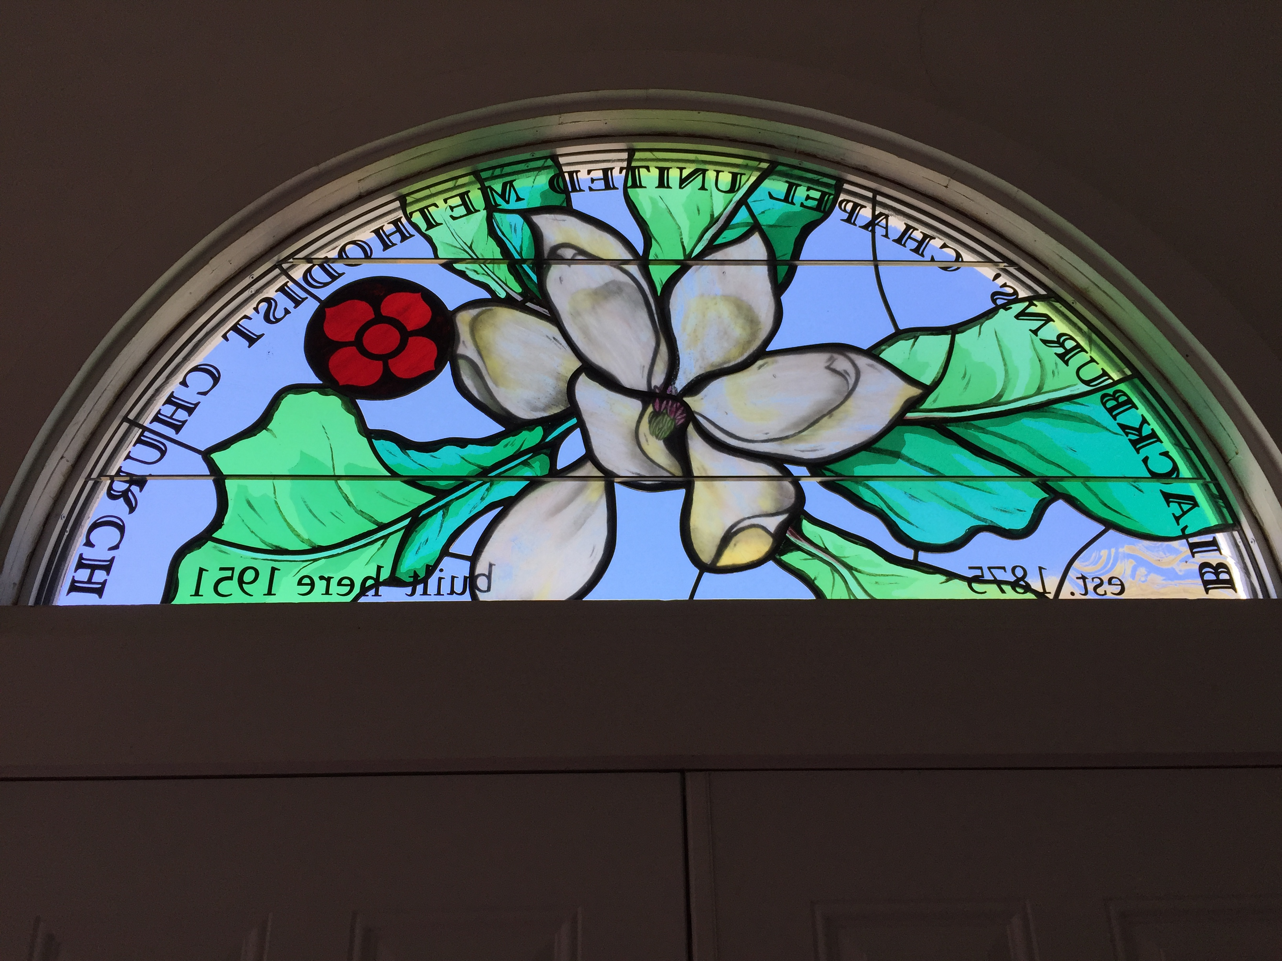
Window 1 (Foyer), the Transom: Welcome! (Fraser magnolia - who/where/when we are)
Come to me, all you that are weary and are carrying heavy burdens, and I will give you rest. - Matthew 11:28

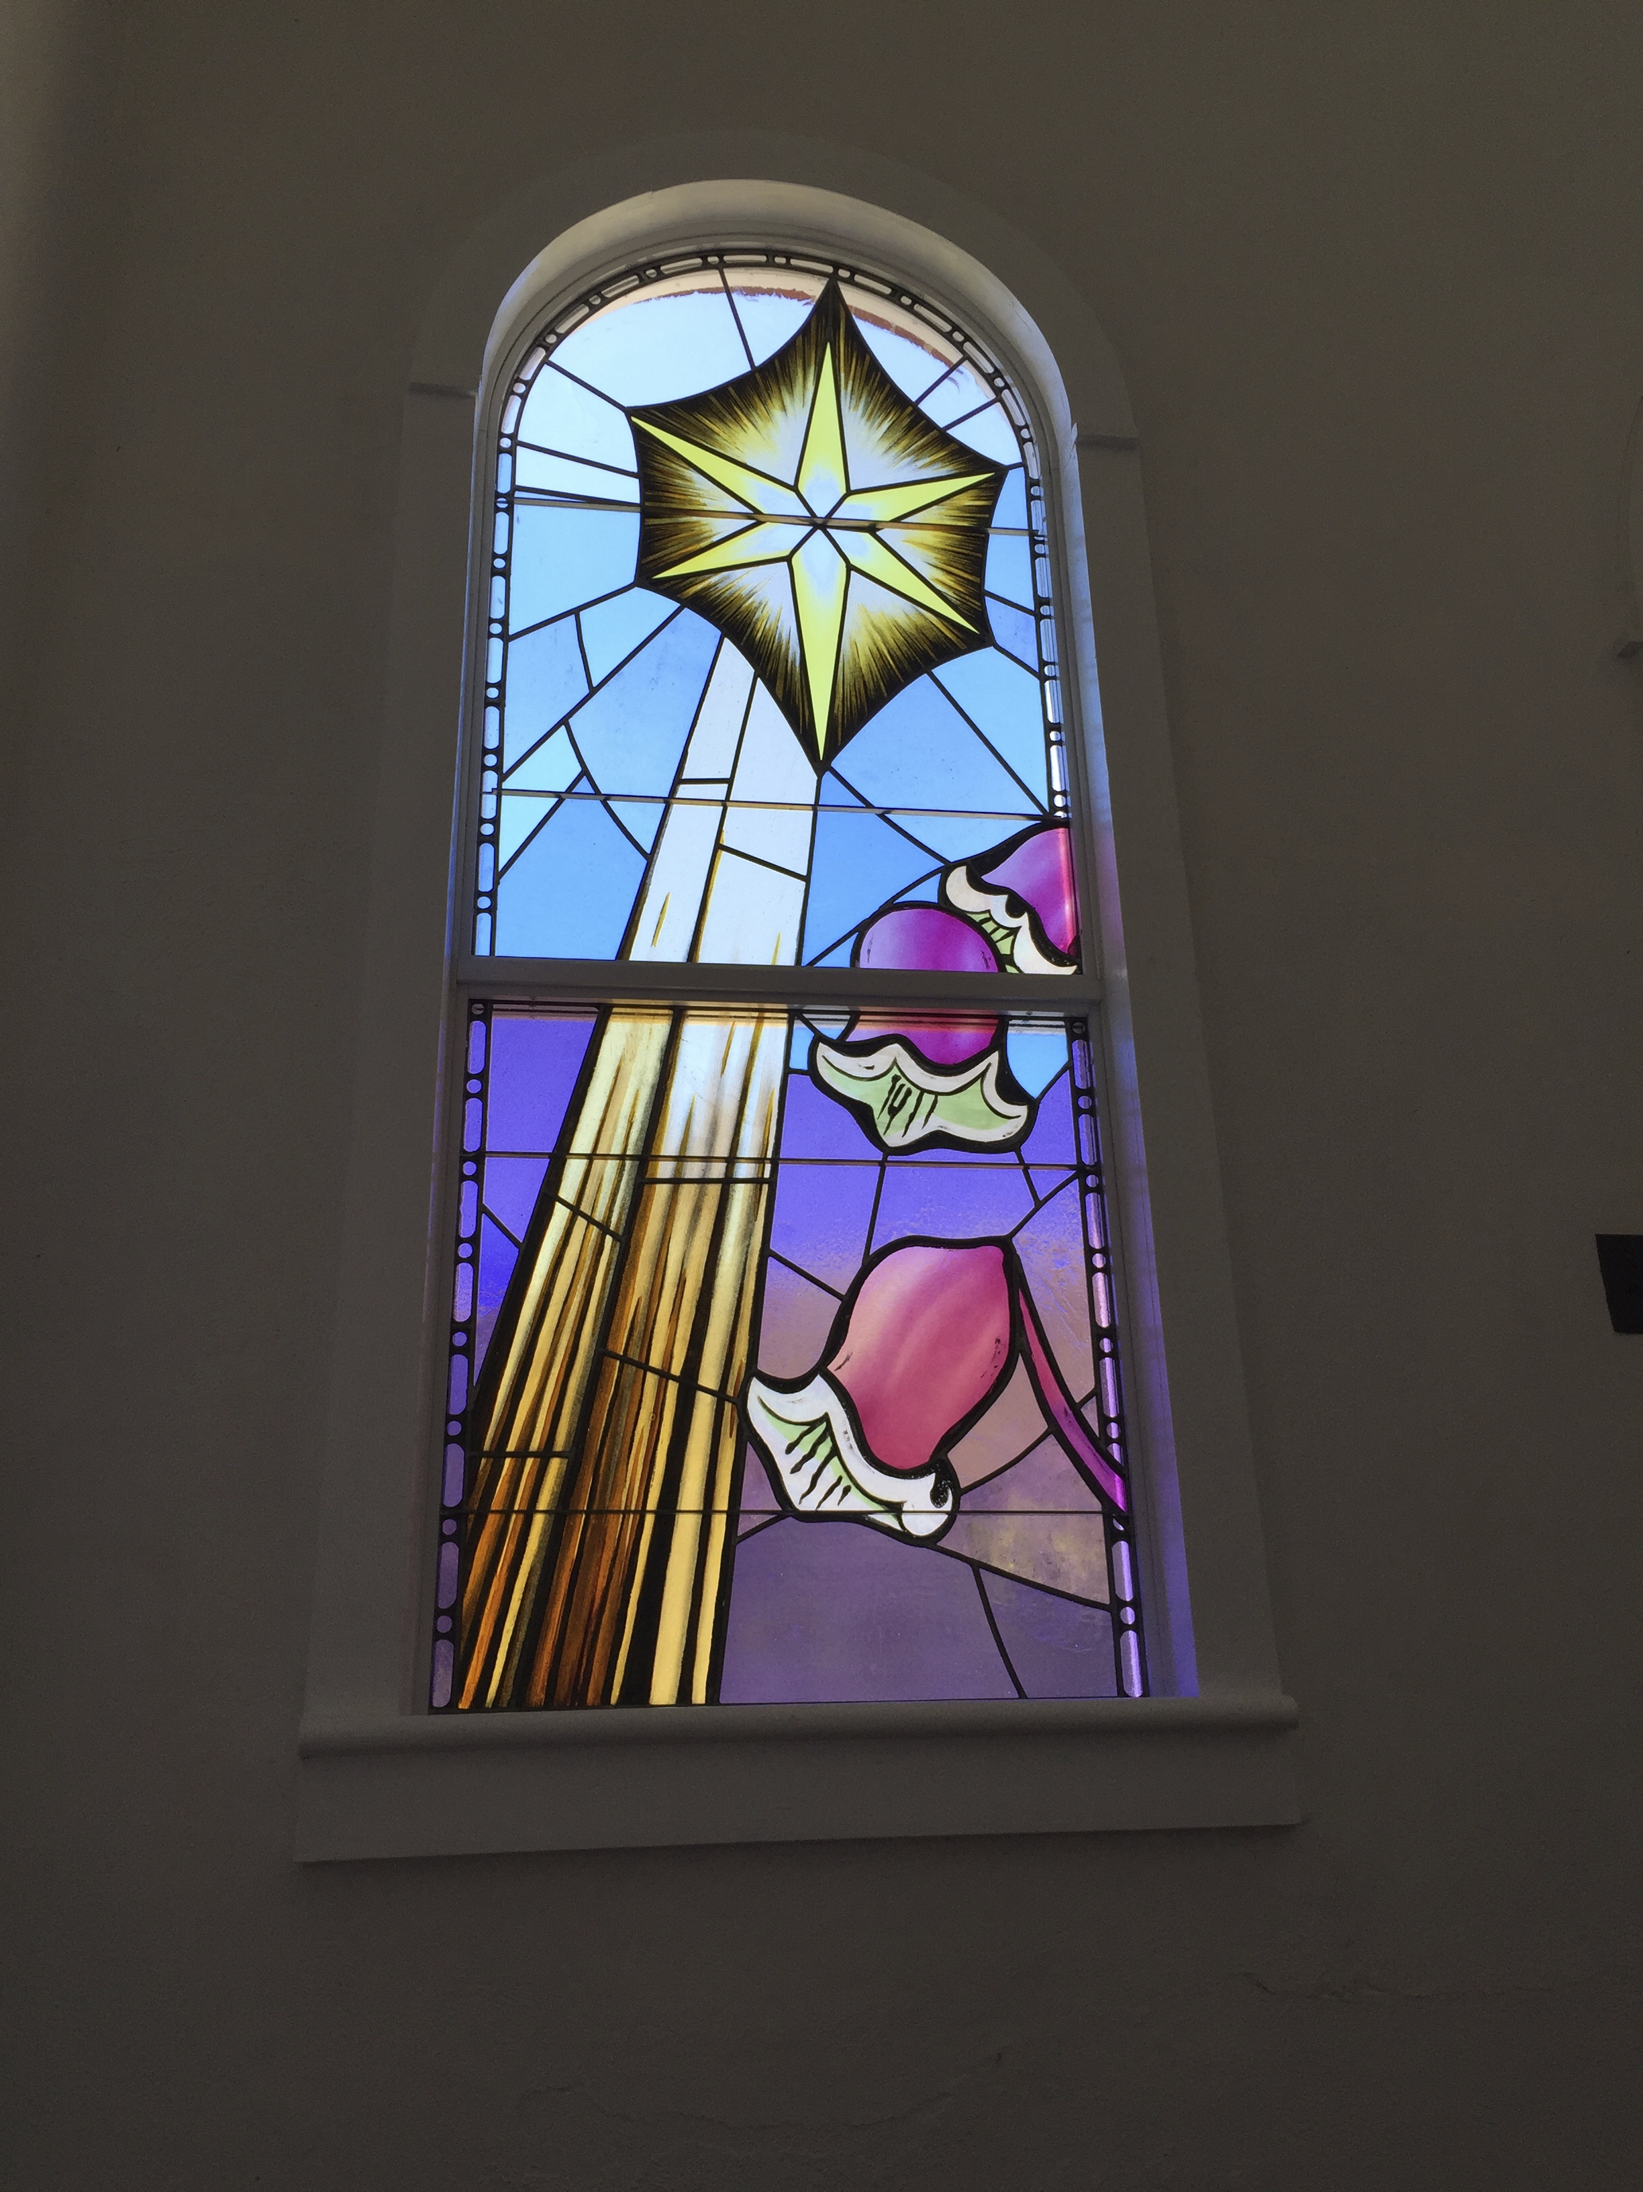
Window 2 (Foyer): Birth/Star (3 stars of wild clematis/Leather Flower)
I have come that you may have life, and have it abundantly. John 10:10
Beloved, let us love one another, for love is from God; and everyone who loves is born of God and knows God. - 1 John 4:7

Enter Sanctuary: Spring and summer on right/south and east (our seasons of youth, growing, multiplying)
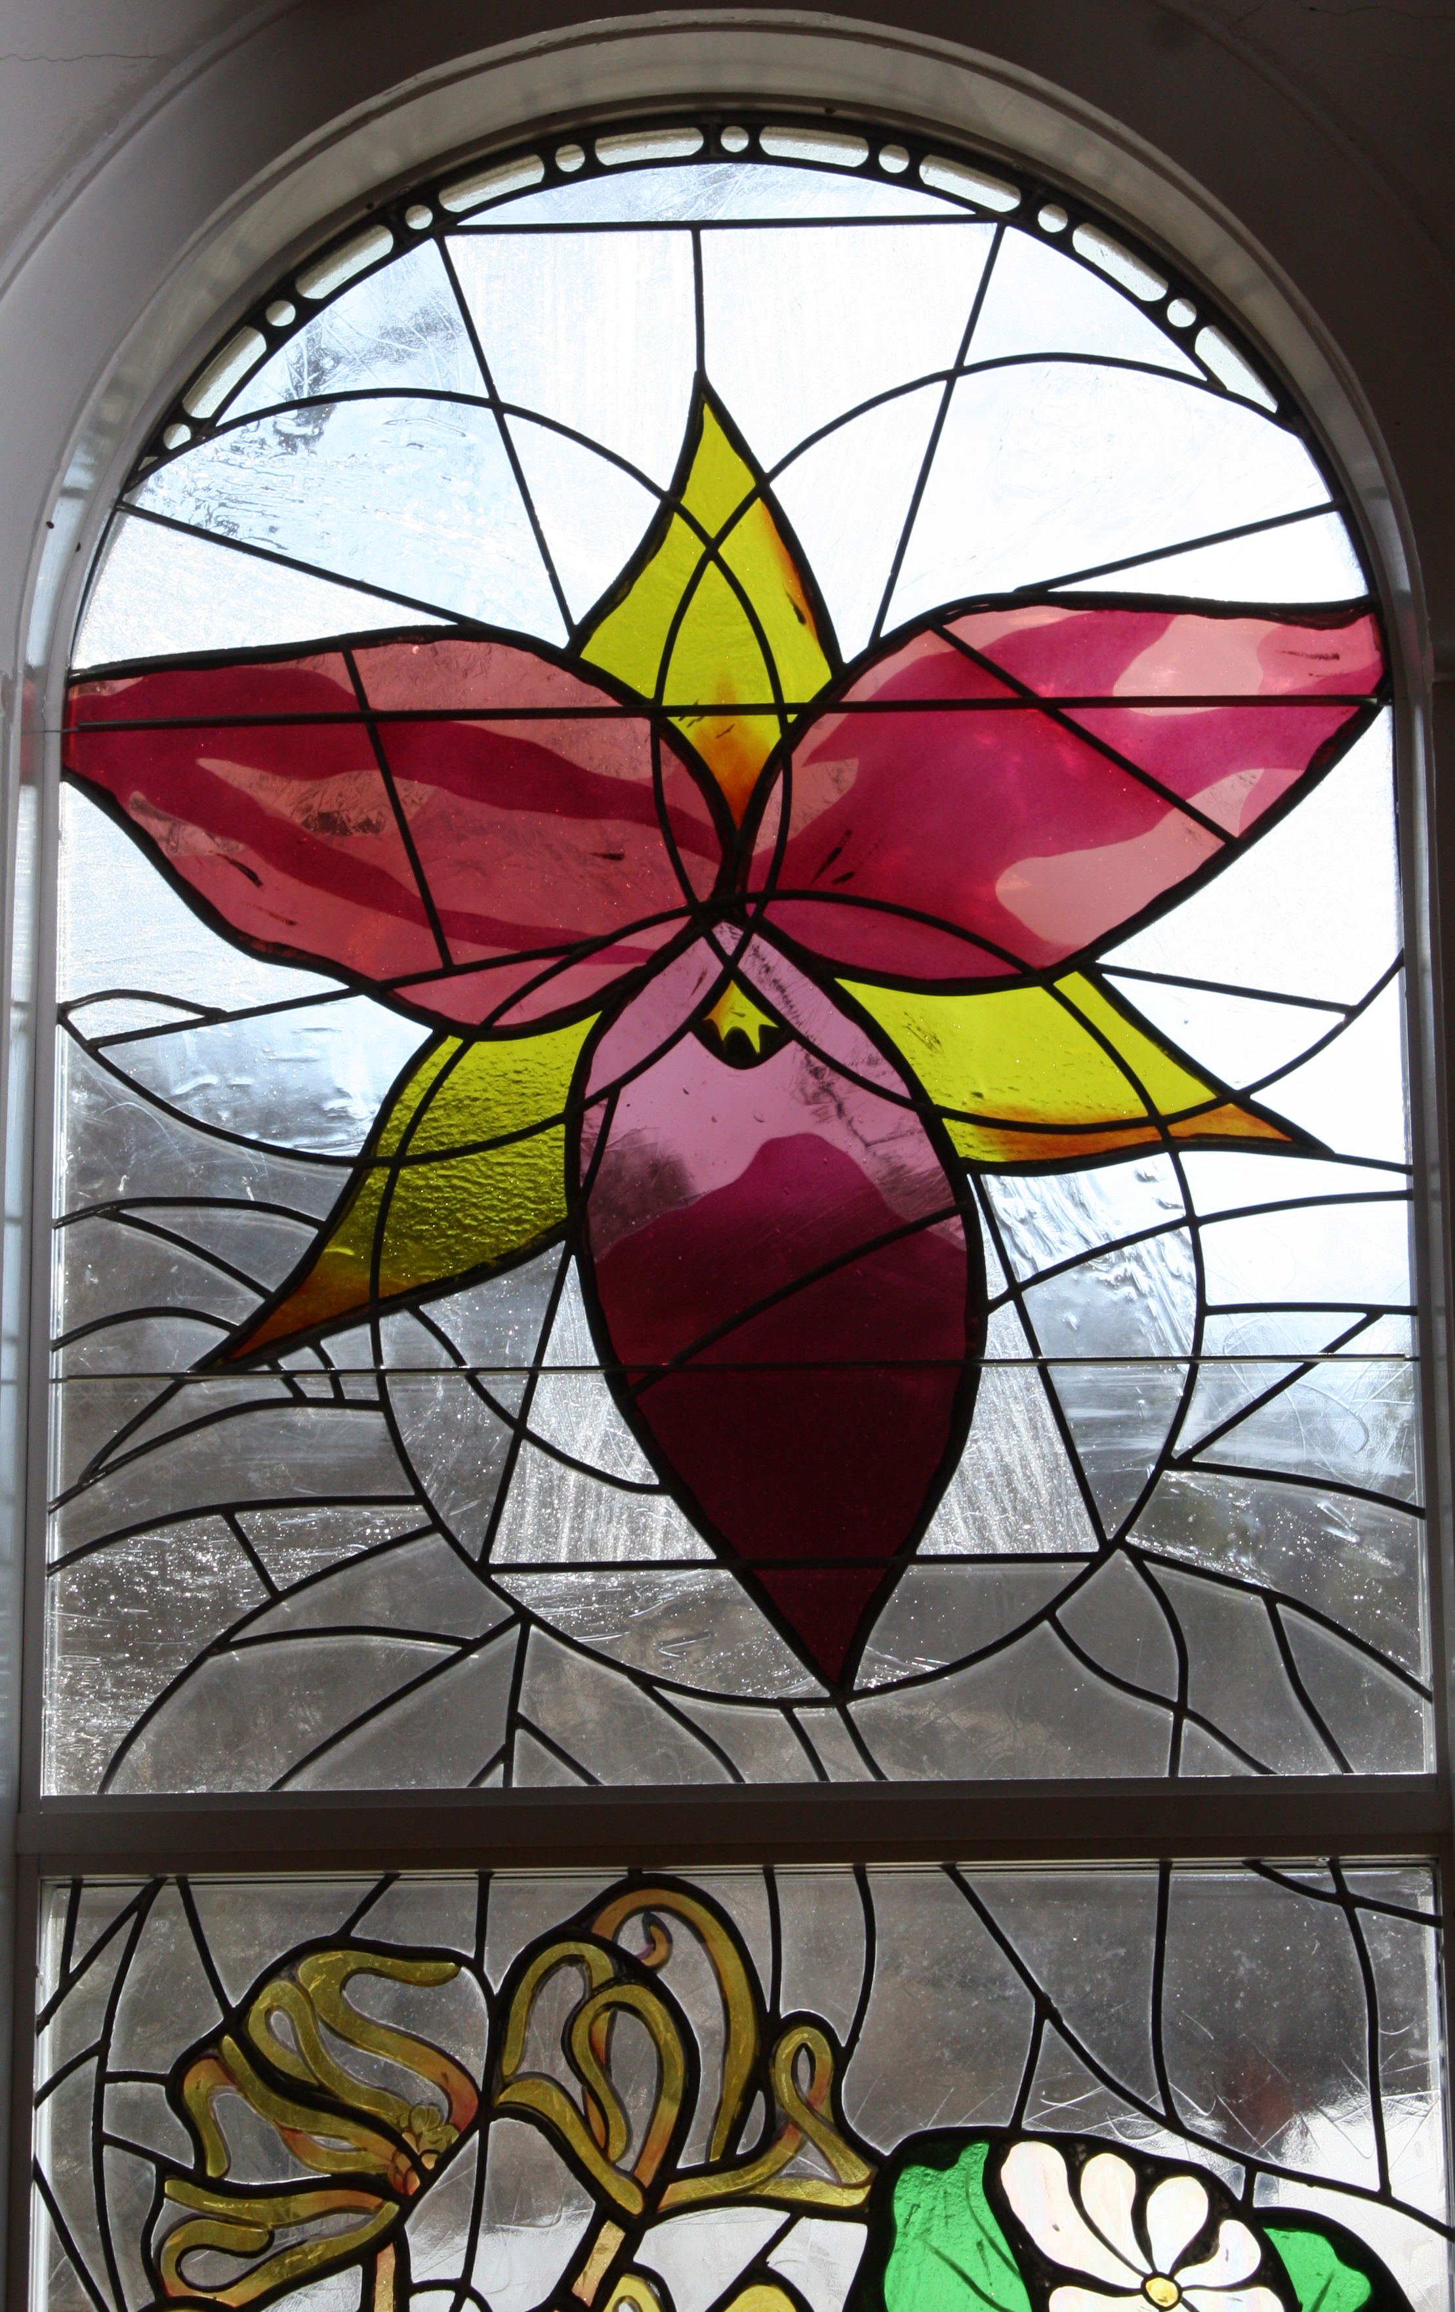
Window 3, Spring: Trinity (trillium (3 petals, 3 petioles, 3 leaves), coltsfoot, speckled trout lily/dogtooth violet, bloodroot, dwarf iris – the spring ephemerals flash their brilliance)
The grace of the Lord Jesus Christ and the love of God and the fellowship of the Holy Spirit be with you all. - 2 Corinthians 13:14

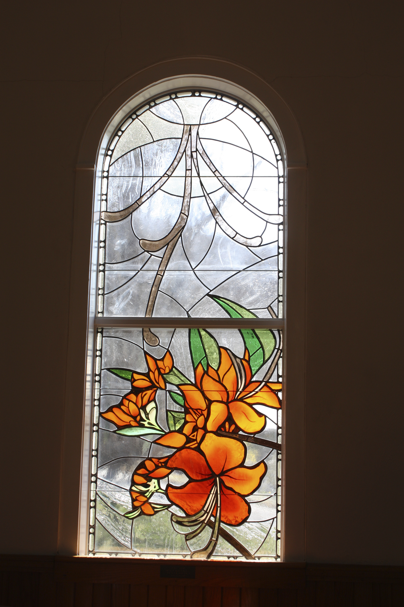
Window 4, Spring: the heraldic Flame (flame azalea – the flame comes to us in the woods)
For the palace will be forsaken, the populous city deserted; the hill and the watchtower will become dens forever, the joy of wild asses, a pasture for flocks; until a spirit from on high is poured out on us, and the wilderness becomes a fruitful field, and the fruitful field is deemed a forest. Then justice will dwell in the wilderness, and righteousness abide in the fruitful field. - Isaiah 32:14-16

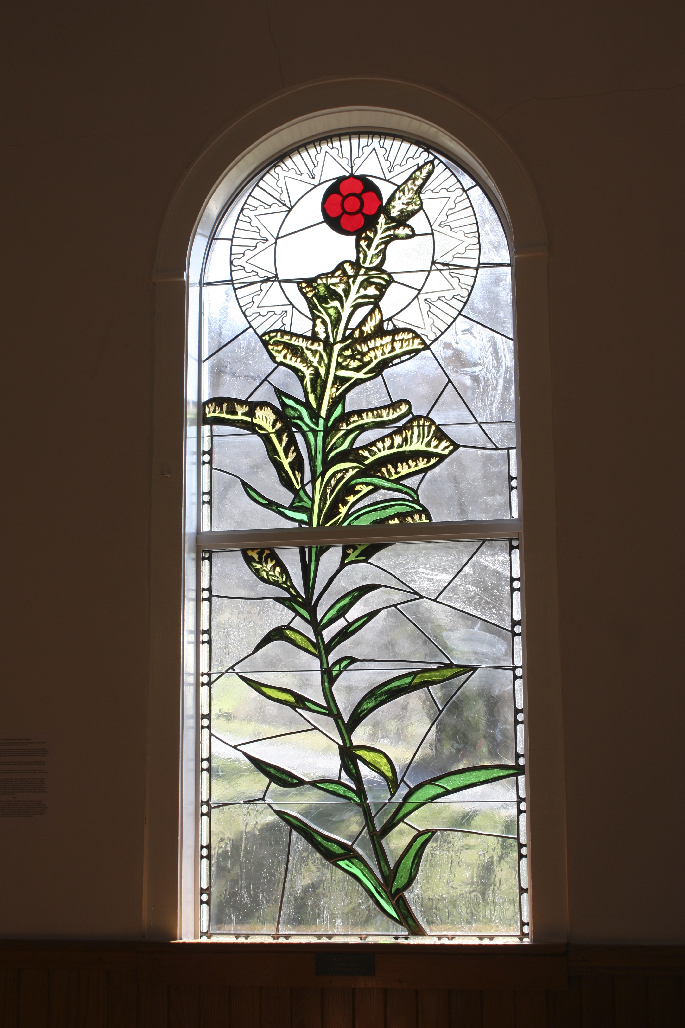
Window 5, Summer: corolla (common goldenrod with ring of light – the long common period)
In the liturgical season of Ordinary Time, the church celebrates the mystery of Christ not in one specific aspect, but in all it’s aspects. We are instructed how to live out faith in our daily lives. The daily pilgrimage is the focus. This is symbolically depicted in Scripture through the theme of “Jesus going to Jerusalem”, Jerusalem being the destination of Jesus’ suffering on the cross. Our pilgrimage through suffering and pain feels slow and determinative. Yet we must fact it; it offers the greatest opportunity for us to connect with our true selves, with others and God.
Jesus went through one town and village after another, teaching as he made his way to Jerusalem. - Luke 13:22
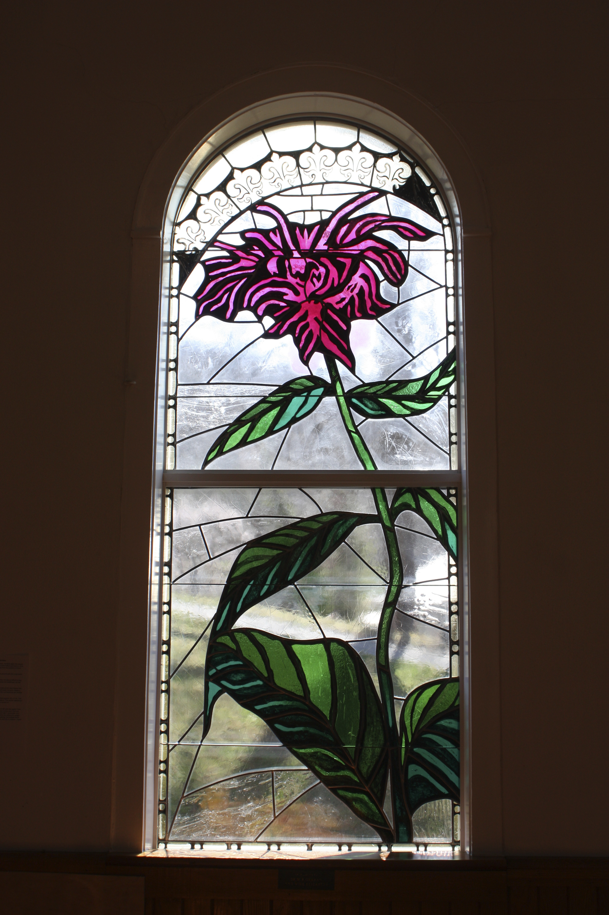
Window 6, Summer: The Balm with the Crown, bleeding – (bee balm/horse mint/bergamot – the healing balm has arrived, a foretaste of bleeding)
For the hurt of my poor people I am hurt, I mourn, and dismay has taken hold of me. Is there no balm in Gilead? Is there no physician there? Why then has the health of my poor people not been restored? - Jeremiah 8:21-22

The Garden of Gethsemane – midlife: the seasons of growth are over, we go down into darkness, time to release the small/false self, learn to rely on faith/trust, to stay awake
“We all have our olive gardens of despair. The key is to realize that life finds its ground in these moments. It is no time to fall into unconsciousness. Indeed, the garden of despair is a portion of bliss, not to be avoided or discounted.” From Writing in the Sand, Thomas Moore, p. 118

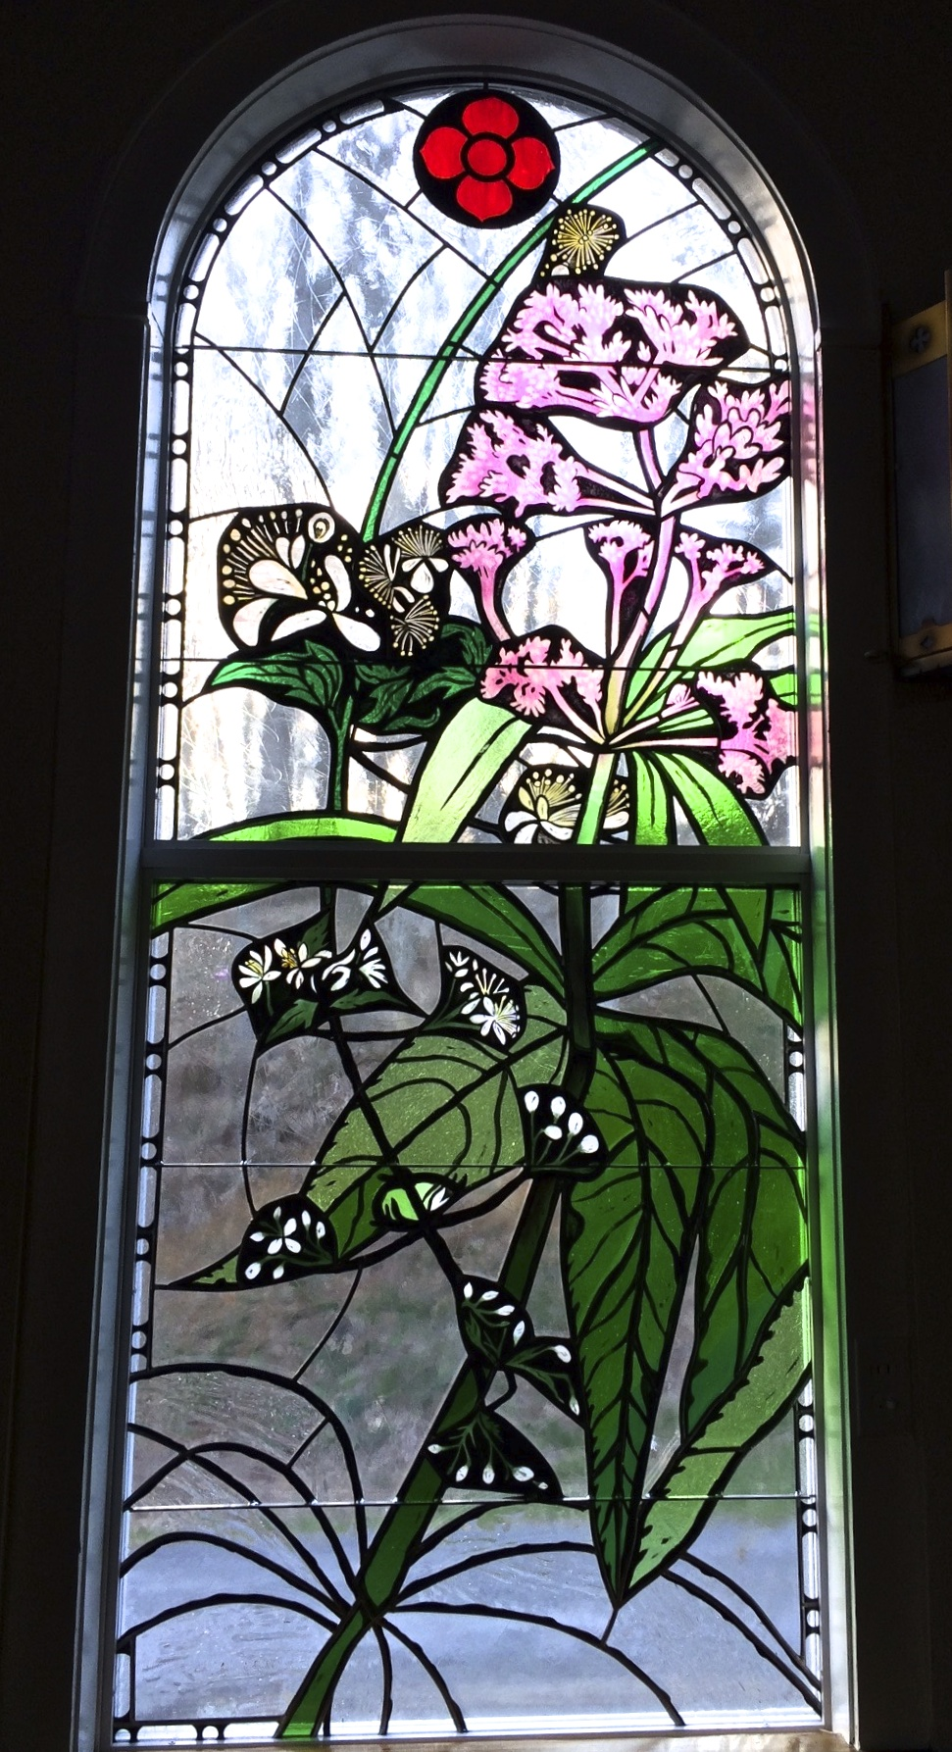
Fall and Winter on north side of sanctuary (our seasons of maturity, fruit/seeds, death)

Window 7, Joe & the Virgin (Joe Pye Weed, Virgin’s Bower – cascading grace, strength)
The Lord is near. Do not worry about anything, but in everything by prayer and supplication with thanksgiving let your requests be made know to God. And the peace of God, which surpasses all understanding, will keep your hearts and your minds in Christ Jesus. - Philippians 4:5-7
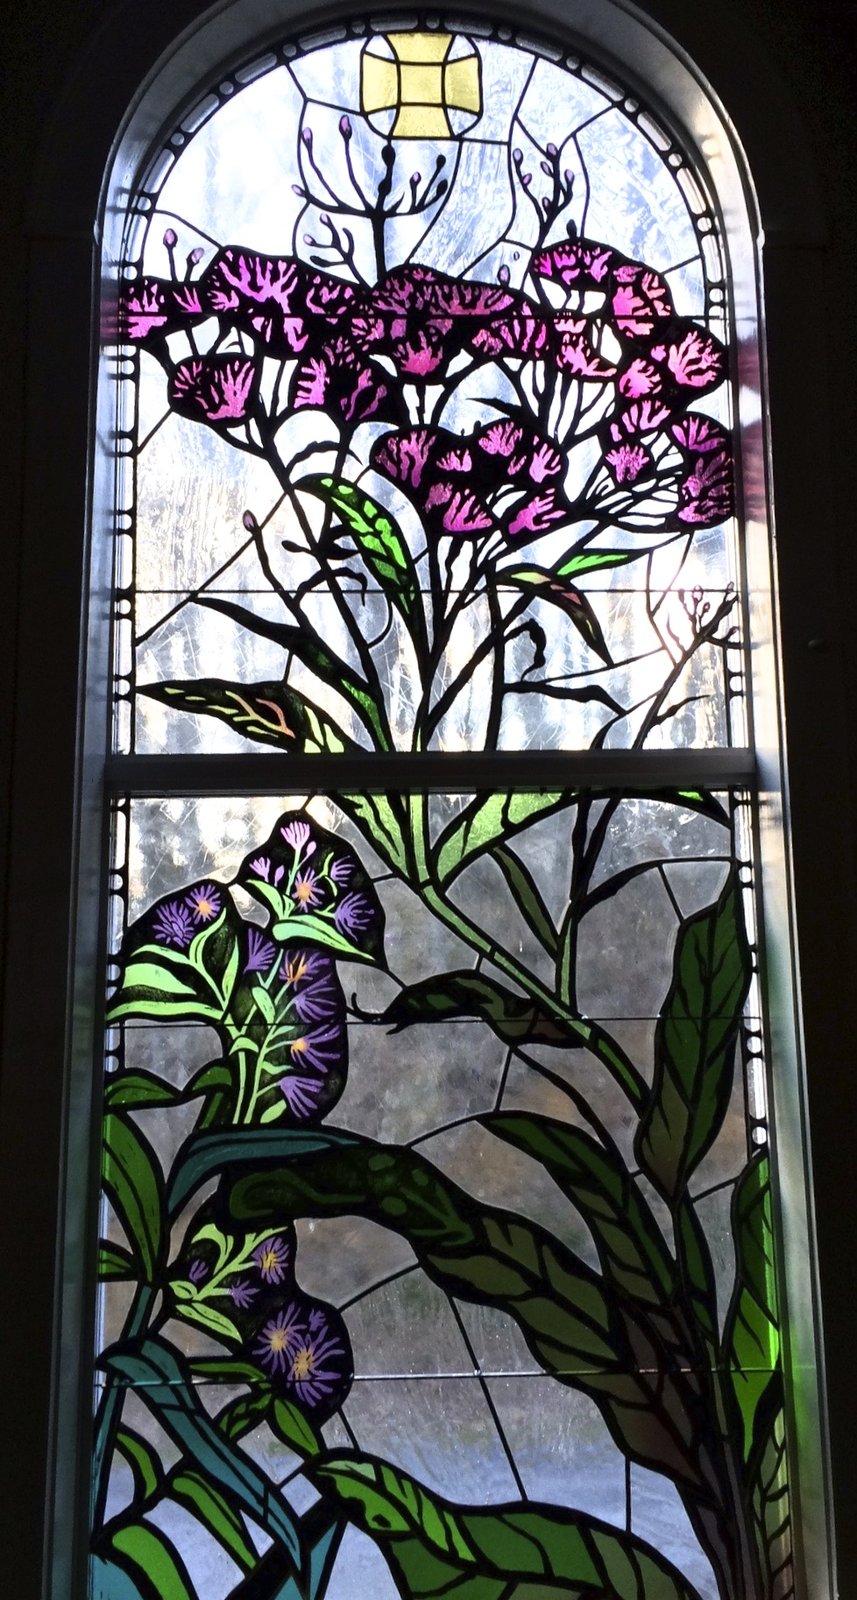
Window 8, Purple majesty (Ironweed, asters – rich mature purples and blues)
I have said this to you, that in me you may have peace. In the world you have tribulation; but be of good cheer, I have overcome the world. - John 16:33

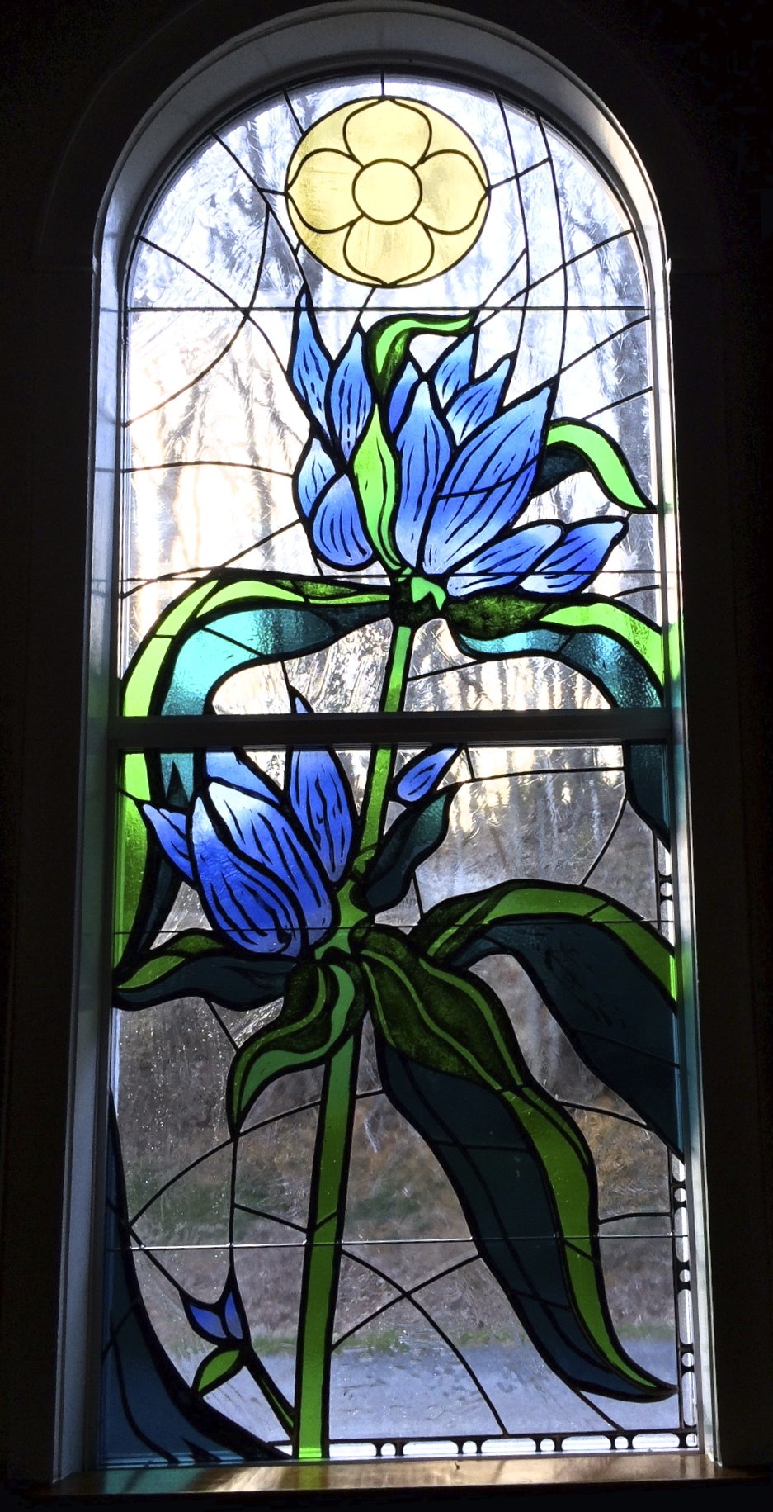
Window 9, Healing Harvest (Blue gentian - during the Middle Ages, Gentian was commonly employed as an antidote to poison. Tragus, in 1552, mentions it as a means of diluting wounds. We have received the antidote.)
Surely he has borne our infirmities and carried our diseases; yet we accounted him stricken, struck down by God, and afflicted. ⁵ But he was wounded for our transgressions, crushed for our iniquities; upon him was the punishment that made us whole, and by his bruises we are healed. - Isaiah 53:4-6

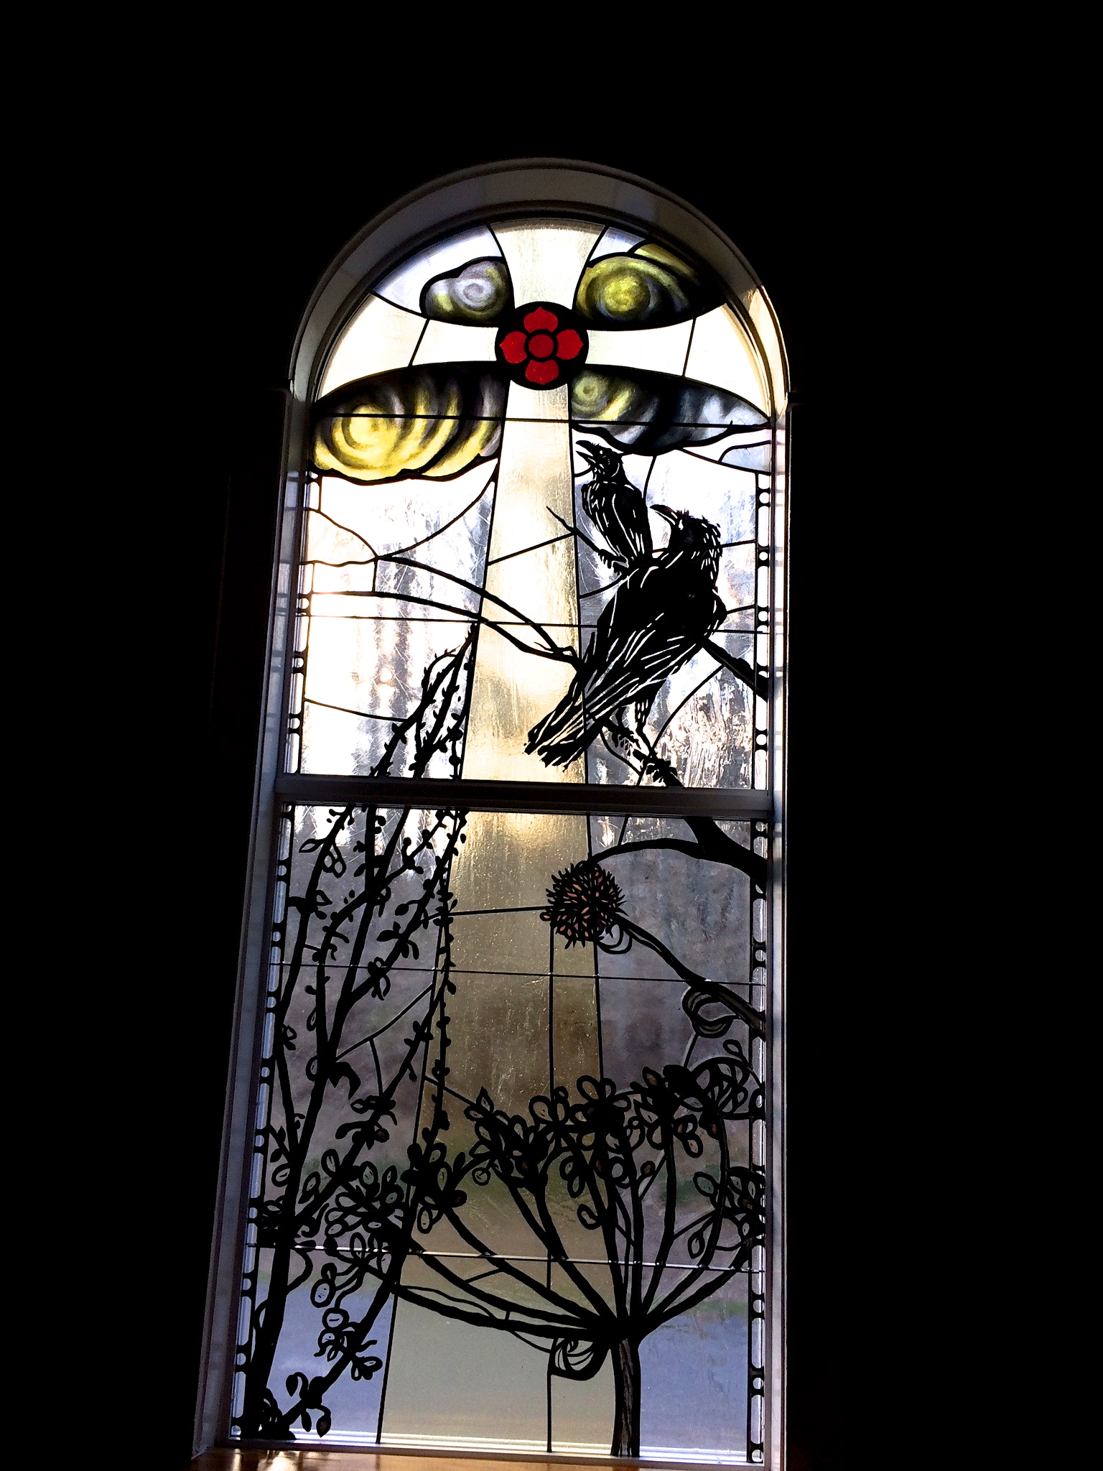
Window 10, Death (The ravens observe death and transcendency, beauty even of the plant skeleton, a period of dormancy, seeds, a new light dawns)
For I am convinced that neither death, nor life nor anything else in all creation, will be able to separate us from the love of God in Christ Jesus our Lord. - Romans 8:38-39

The Portal of Death (Exit through death below The Cross)
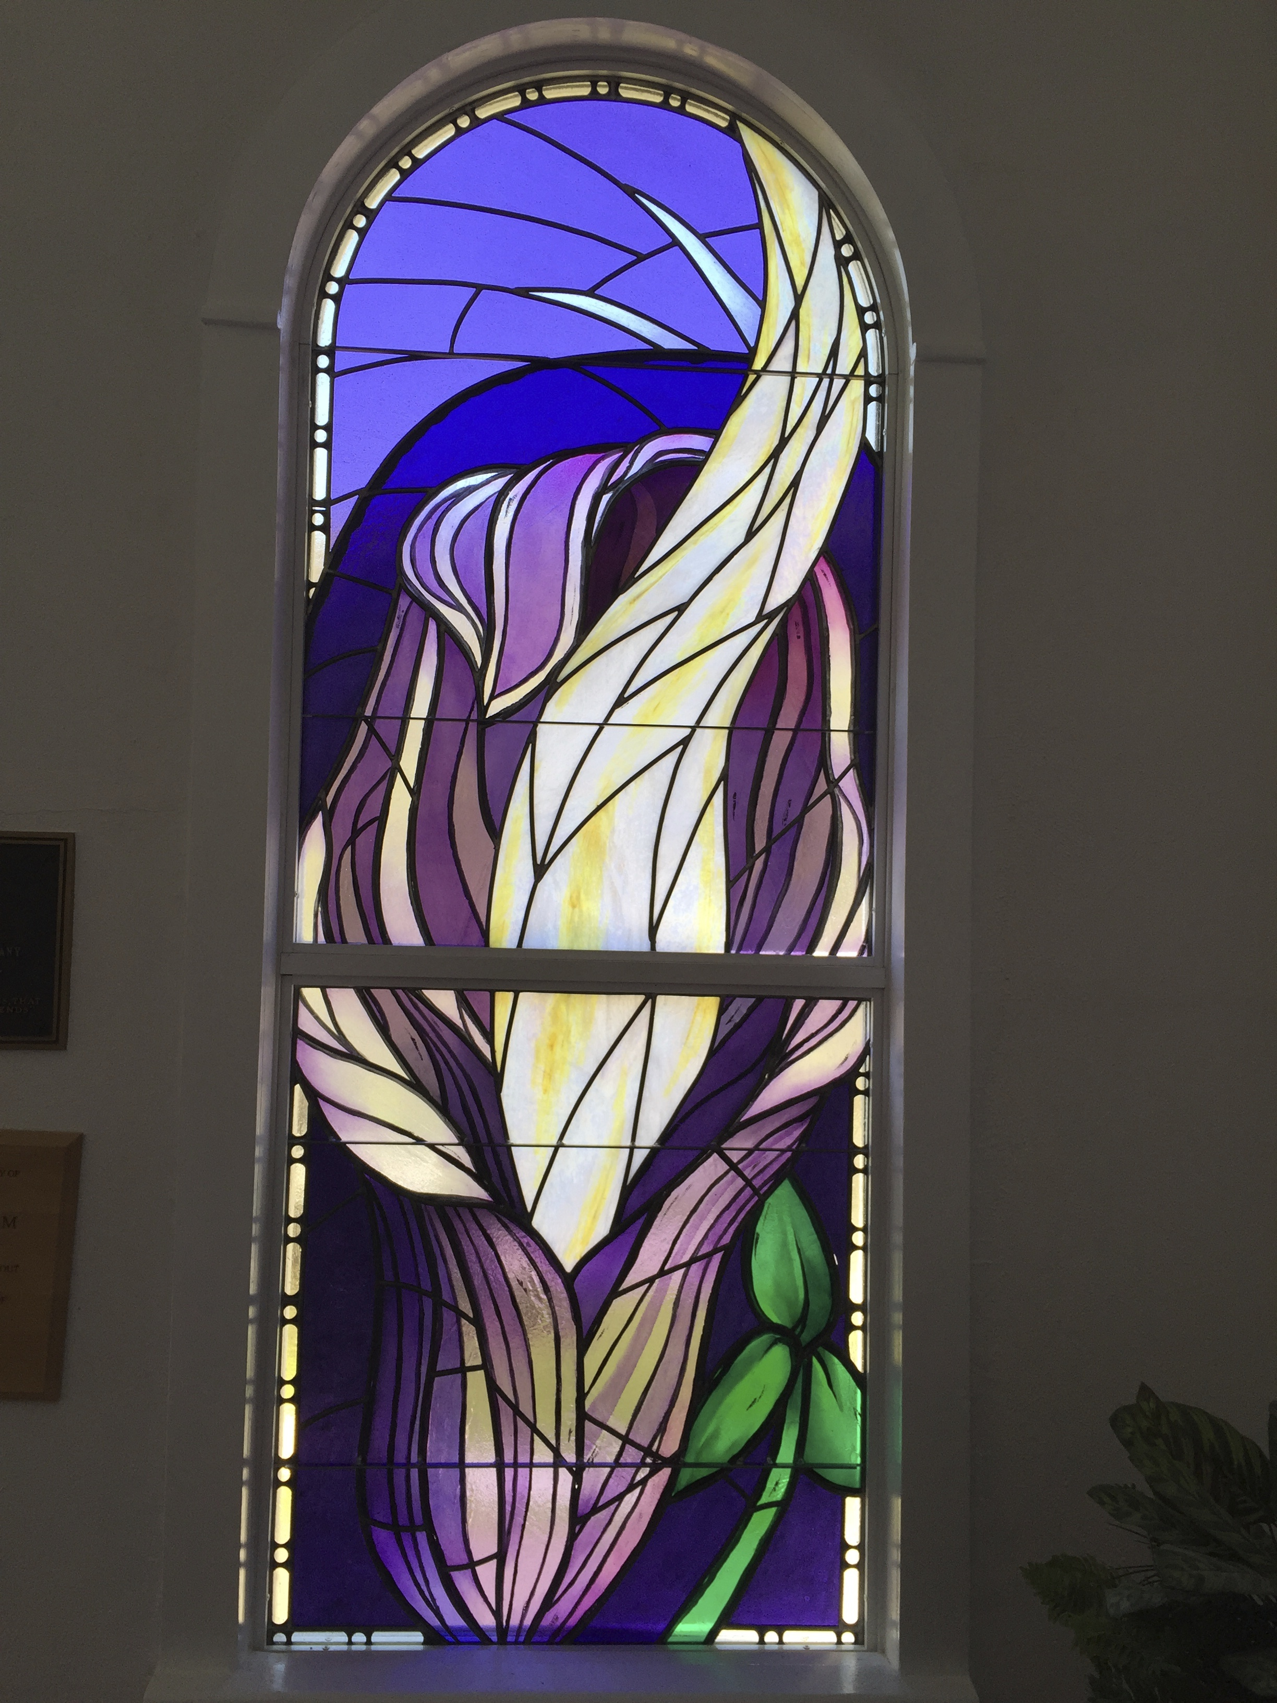
Window 11 (Foyer), Ascension: (Jack-in-the-pulpit, the spirit rises, Methodist flame) So if anyone is in Christ, there is a new creation: everything old has passed away; see, everything has become new! - 2 Corinthians 5:17

